Practical No 24

VIII. Resources required (Additional)
→ If any web resources required.

Resources used (Additional)
https://www.tutorialspoint.com/vb.net/vb.net

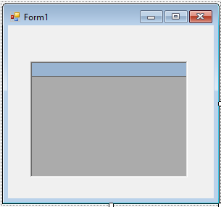Program Code
  - Write a program using ADO.Net to the database.

Imports System.Data Imports System.Data.OleDb

Public Class Form1

Private Sub Form1_Load(sender As Object, e As EventArgs) Handles MyBase.Load Dim conn As New OleDbConnection("Provider=Microsoft.Jet.OLEDB.4.0;Data " &
"Source=C:\Users\Suresh\Documents\Visual Studio 2012 \ Projects \ Datagrid \ stud.mdb")
Conn.Open()
Dim cmd As New OleDbCommand("Select * From Marks", conn) Dim da As New OleDbDataAdapter(cmd)
Dim ds As New DataSet da.Fill(ds, "Marks") DataGrid1.CaptionText = "marks" DataGrid1.DataSource = ds DataGrid1.DataMember = "marks"

End Sub End Class

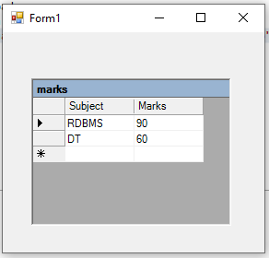Output:

Practical related Questions
  - Find error from following code
Dim con As New OleDbConnection("Provider=Microsoft.Jet.OLEDB.4.0DataSource=D:\mydata.accdb;")

Error 1 Type expected.
Error 2 'OleDbConnection' is a type and cannot be used as an expression. Error 3 'Conn' is not declared. It may be inaccessible due to its protection level.

  - Write a connection string with MS-access using any database.
- Provider=Microsoft.Jet.OLEDB.4.0;Data Source=C:\MyDB.accdb

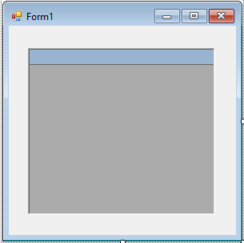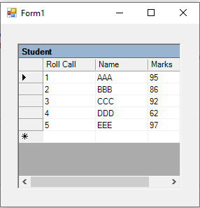
- ercise
  - Design the windows application that will display the content of a table in MS-Access database on DataGrid control using data adapter.
➢

Imports System.Data Imports System.Data.OleDb Public Class Form1

Private Sub Form1_Load(sender As Object, e As EventArgs) Handles MyBase.Load Dim conn As New OleDbConnection("Provider=Microsoft.Jet.OLEDB.4.0;Data” &
“Source=C:\Users\Suresh\Documents\Visual Studio 2012\Projects\DataGrid1\student.mdb")
conn.Open()
Dim cmd As New OleDbCommand("Select *From Student", conn) Dim da As New OleDbDataAdapter(cmd)
Dim ds As New DataSet da.Fill(ds, "Roll Call")
DataGrid1.CaptionText = "Student" DataGrid1.DataSource = ds DataGrid1.DataMember = "Roll Call"

End Sub End Class

OUTPUT:

